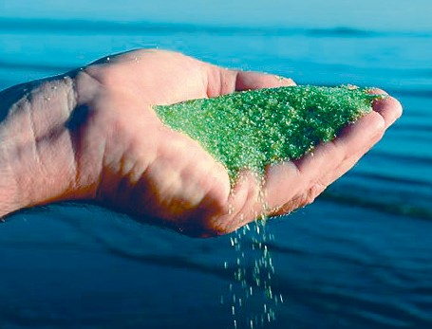AFM®
Activated Filter Media
Factsheet for public
Swimming Pools

What is AFM®?

AFM® Activated Filter Media is a direct replacement for quartz sand in any sand filter. It is made from recycled green and brown container glass. AFM® filters twice as good as sand and will last much longer. AFM® minimizes the formation of harmful disinfection by-products (DBP’s) such as Trichloramines and THM’s and will save operating costs.

Why only green and brown glass, and what does «activated» mean?

Green and brown glass contain certain metal oxides. These metal oxides, in combination with the activation process, give the surface of AFM® its unique catalytic properties. When in contact with water flowing through the filter, a small amount of free radicals are formed on the surface of the grains. These free radicals will protect AFM® from colonization by bacteria and subsequent formation of biofilm.

In addition, the activation process increases the negative electrical surface charge of AFM®. Like a magnet, positive and dipolar charged particles coming through the filter are attracted by the AFM® grains, thereby increasing filtration performance. In addition to its mechanical filtration properties, AFM® therefore benefits from electrostatic filtration. This is why AFM® filters at least twice as good as sand.

It is the media that does the filtration, not the filter vessel. The filter vessel is the hard- ware, the filter media is the software. For best filtration, you therefore need the best filter media: AFM®!

Why is activation important?

One of the main differences between AFM® and other filter media such as sand and crushed glass is its bio-resistance. As a result, bacteria can’t attach on the surface of AFM® and therefore can’t form biofilm.

What is biofilm and why is it a problem?

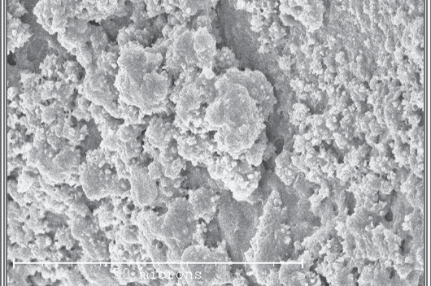Within just a few days, heterotrophic bacteria will colonize all surfaces in contact with water. The largest surface in contact with water in a public swimming pool is the quartz sand in the filter. 1 ft3 of quartz sand has a surface of 900 ft2 and it is an ideal breeding ground for bacteria. Heterotrophic bacteria will attach to the surface of the sand grains and, within seconds, will form a biofilm that protects them from
oxidants. In this protective biofilm, bacteria can grow and multiply quickly. At 86°F water temperature, they can double in mass every 30 minutes. Even the highest chlorine concentrations and the most aggressive backwashing can’t stop this development.

Biofilm in swimming pools leads to the following 3 issues in a pool system:

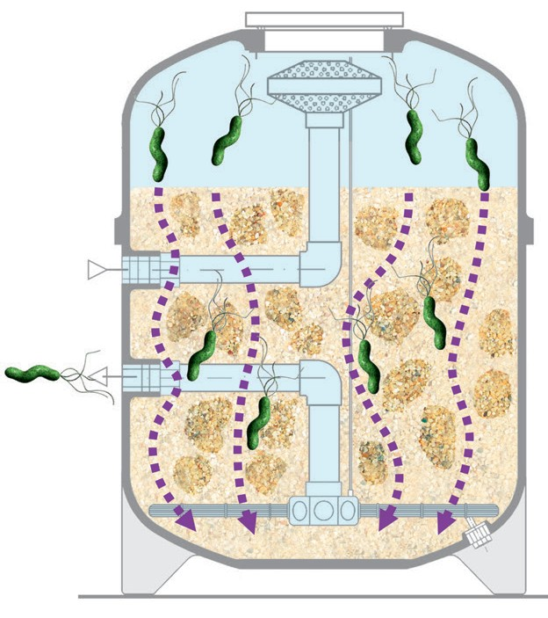1. Inconsistent and unreliable filtration: After 6 – 12 months, biofilm on the sand has developed to a degree where the grains stick together, forming clumps and causing channeling of the filter bed that reduce filtration performance. Turbidity and chlorine consumption will increase. Periodically, bacteria flocs will break through the filter. The filter now no longer offers a reliable safety barrier against chlorine resistant pathogens like Crypto that could otherwise be filtered out. AFM® solves this problem.

2. Pathogens: The filter develops into a breeding ground for pathogens, such as amoebae that live in biofilm and legionella that lives and multiplies inside amoebae. Without biofilm, the legionella risk will be reduced by over 90%. This is also true
when AFM® is used to support adsorption media such as Activated Carbon.

3. Trichloramine – chlorine smell: Pool users add sweat and urine in the pool water. They consist of 80% of urea (organic). Urea is a food source for heterotrophic bacteria, and bacterial enzymes (urease) convert urea into ammonia. Ammonia will react with chlorine to form mono-chloramine, di-chloramine and tri-chloramine. Tri-chloramine is very volatile, will off-gas out of the water and is responsible for the typical chlorine smell. With the use of AFM®, this conversion process is practically eliminated.

Our approach:
Prevent growth of bacteria rather than kill them

Less THM’s and better filtration

Trihalomethanes (THM), including Chloroform, will form when organic substances are not fully oxidized and then react with chlorine.

AFM® filters 30 – 50% more organic substances than sand. This can be confirmed by measuring the TOC (total organic content) or KMnO4- consumption. This is why AFM® reduces THM formation by 30 – 50%.

Only the volatile disinfection by-products (DBP’s)
are dangerous

The highest THM and Trichloramine concentrations occur directly above the surface of the pool water, exactly where pool users will inhale them. Trichloramines will damage the protective layer of the lungs and can lead to long term damage and asthma. Chloroform will pass the lungs to reach the bloodstream and nerve system.

Info box
• In the US there is an official disease called
„lifeguard lung“. In 1998 for the first time a
relation between Trichloramine/THMs and
lung damage was proven and since then
several times confirmed.

• Dolphins in captivity live in chlorinated systems - in „normal“ swimming pools. They inhale the air that is directly above the water surface, where the concentration of toxic gases is very high. We should not therefore be surprised that lung diseases and pneumonia are amongst the most common health problems in captive dolphins.

• Dr. Howard Dryden researched the provenance of chlorine disinfection by-products at university more than 30 years ago and developed a solution that stops their development at source. The result of his research and development work is AFM®

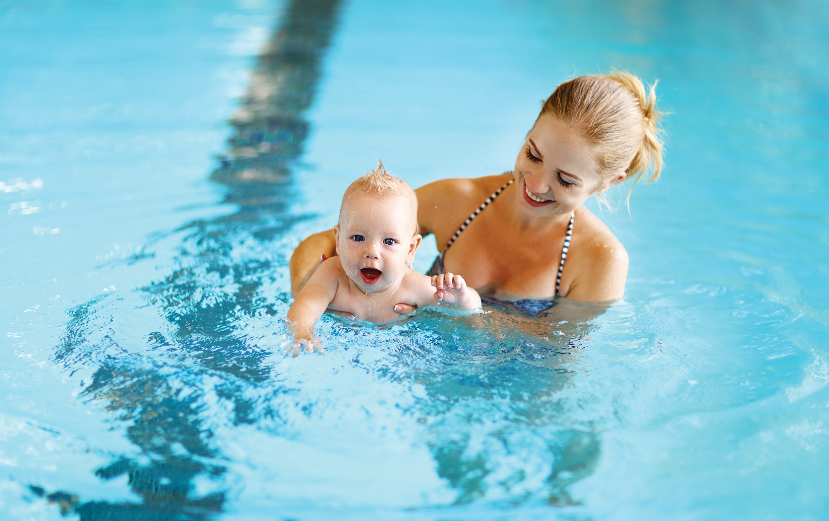

Both gases are especially dangerous for small children less than 2 years old, because their blood-brain barrier is not yet fully developed, AFM® reduces both gases by up to
30 - 50%!!!

What is the filtration performance of sand, glass sand and AFM®?

The independent and best-known European laboratory for filtration tests IFTS (www.ifts-sls. com) has tested AFM®, quartz sand and various glass sands. The tests were conducted with fresh filter media without any biofilm. For example, at 8 gpm filtration velocity, without the addition of flocculants, the following results were achieved:

• AFM®: Filters 95% of all particles down to 4 microns

• Sand: Filters 95% of all particles down to 20 microns

• Best glassand: Filters 95% of all particles down to 26 microns

Result: AFM® is the highest performing filter media

Particle size removal performance

100.0

90.0

80.0

70.0
Removal performance [%]

60.0

50.0

40.0

30.0

20.0

AFM® 0
AFM® 1
Sand 16x30
Garo Astral Bioma EGFM
Vitrosphere

10.0

0.0

0 5 10 15 20 25 30 35 40
Size of particles [μ]

What is the difference between AFM® and glass sand?

• Raw material: We only use green and brown glass in the manufacture of AFM®, because white glass does not contain the metal oxides needed to make the media bio-resistant.

• Purity: AFM® is the purest glass filter media on the market with a maximum organic contamination of less than 1.5 oz/ton. Normal glass sand has up to 600oz/ton.

• Activation: AFM® is the only activated glass filter media. The negative surface charge is increased by increasing the surface through a 3-step treatment process. This gives AFM® the highest filtration efficiency and the greatest bio-resistance. AFM® is certified to be used in drinking water in the UK, USA and many other countries.

The performance of AFM®

• AFM® is bio-resistant. The result is 50% less Trichloramines and therefore 50% less chlorine odor (see test Bad Hesselingen, Netherlands, last page). Healthier air for pool users, children and employees, and less corrosion on buildings and installations.

• No clumping or channeling of the filter bed with AFM® means better and more consistent filter performance over many years.

• AFM® reduces the risk of transmission of pathogens like legionella and pseudomonas by
80 – 90%

• AFM® filters twice as good as sand for crystal clear water

• AFM® will save up to 50% backwash water because its backwash velocity is only 18 gpm (instead of 24 gpm needed for sand) and offers better backwash efficiency (3 minutes instead of 6 minutes). The payback for AFM® is therefore less than 2 to 5 years – for indoor and outdoor pools.

What about combined chlorine and AFM®?

AFM® will not form less combined chlorine (chloramines). However, the level of inorganic chloramine (Mono-, Di- and Trichloramine) is 2 to 5 times lower, while the level of organic chloramine is slightly higher. Organic chloramines are not volatile and non-toxic compared to Trichloramines. This is why 2-4 in. of Activated Carbon (coconut shell) can be added on top of the AFM® filter bed. This small layer will avoid microbial contamination of the activated carbon while adsorbing organic chloramines leading to maximum levels of 0.2 ppm of combined chlorine – even under heavy bather load.

Outdoor pools usually have less of an issue with chloramines. The use of Dryden Aqua
ACO® amplifies the natural disinfection power of the sun and reduces combined chlorine by
30 – 50%. Chlorine consumption will also be reduced.

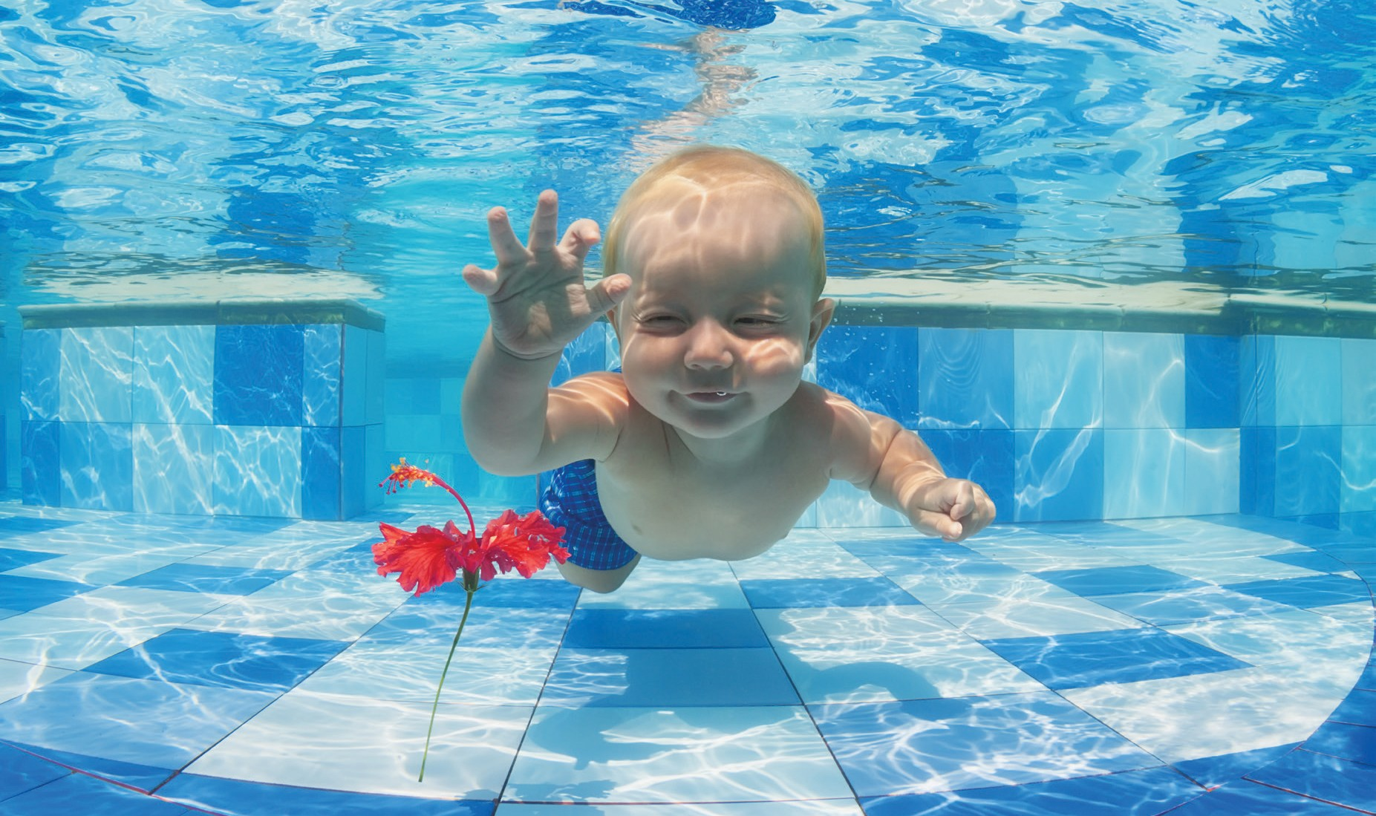

Life expectancy of AFM®

Due to its bio-resistance and hardness, the life expectancy of AFM® is much greater than sand and will last for over 20 years if the filters are backwashed properly.

What are the investment costs?

AFM® costs approximately twice as much as good quartz sand. The MSRP is about $1/per lb delivered. AFM® (78 lbs/ft³) is 15% lighter than sand (90 lbs/ft3). This means for example to replace 22,000 lbs of sand, you will only need 18,700 lbs of AFM®.

For a typical 25 yard public pool this could mean:

• 18,700 lbs of AFM® at $1/lb delivered = $18,700

• 22,000 lbs of sand at $.5/lb deliverd = $11,000

The additional investment is therefore only $7,700.
The life expectancy of AFM® is over 20 years! What are the operating costs?

Operating and maintenance costs with AFM® are significantly lower than with sand:

• Water savings: Sand needs to be backwashed at 24 gpm for 6 min. AFM® only needs
18 gpm backwash velocity. The backwash efficiency is higher, because no biofilm is
coagulating the grains and a backwash duration of 3-4 minutes is usually enough. As a result, approx. 50% of the backwash water can be saved. Water costs are approx. $.01/gal for water and $0.015/gal for heating and treatment.

• Chemical savings: what is filtered out does not need to be oxidized. The greater filtration efficiency of AFM® therefore saves chlorine and acid. Chemical savings are approx. 20-
30%.

• A major cost factor is the cost of replacing the media (removal, disposal, change of nozz- les/laterals and filling with new media). These costs are the same for AFM® and sand, but the life expectancy of AFM® is 3-4 times higher than sand.

The payback for the incremental cost of AFM® compared to sand is therefore usually less than 2 years for indoor pools!

Applications for AFM®

In addition to use as a replacement for sand, AFM® can be used as a support layer for activated carbon, anthracite, pumice and others. Due to AFM®’s bio-resistance, it will avoid the formation of contamination and biology in the support layer. In addition, these media can normally only be backwashed at a max. 18 gpm in order to prevent the loss of media. This is another reason why AFM® is a better support layer than sand.

Sustainability and responsibility

• Sand is a finite raw material that is being used for many different applications, for example the construction industry. When mining sand, landscapes are destroyed, and entire ecosystems disappear. Processing and transport are energy inefficient. AFM® is manufactured from recycled glass, a raw material that already exists and needs to be reused.

• Due to the lower consumption of disinfectants and water, operating cost are saved.
Better air quality improves the use of swimming pools for all users and for employees
and makes it safer. In addition, it protects the environment.

• As a public pool owner or operator, you are responsible for the safety and well- being of your guests and employees. In addition, you owe it to the taxpayer to use your resources economically.

Our Mission

Our mission is to provide solutions that have a positive environmental impact on our ecosystem. We help to make this world a better place: a non-toxic environment for everyone.

Major performance test
A performance test has been conducted in the Nether- lands at an existing indoor swimming pool over a period of 18 months. The following was tested:

Phase 0: Sand with flocculation
Phase 1: AFM® with APF® (flocculant) – no carbon Phase 2: AFM® with APF® and UV (low pressure) Phase 3: AFM® with APF® and 4 in. of activated
carbon (coconut shell)

36 different chemical and biological parameters were tested, once per month on the same weekday and at the same time to best compare the conditions in the pool. The tests were conducted by C-Mark, the largest laboratory in the Netherlands. All original test protocols can be made available (in Dutch).

The table below summarizes the most important para- meters
Project data „Bad Hesselingen“
Pool: Public indoor pool Location: The Netherlands
Size: 25 yards x 15 yards
Visitors: ø 5‘500 per week Testing laboratory: C-Mark
Testing period: 2015 - 2017

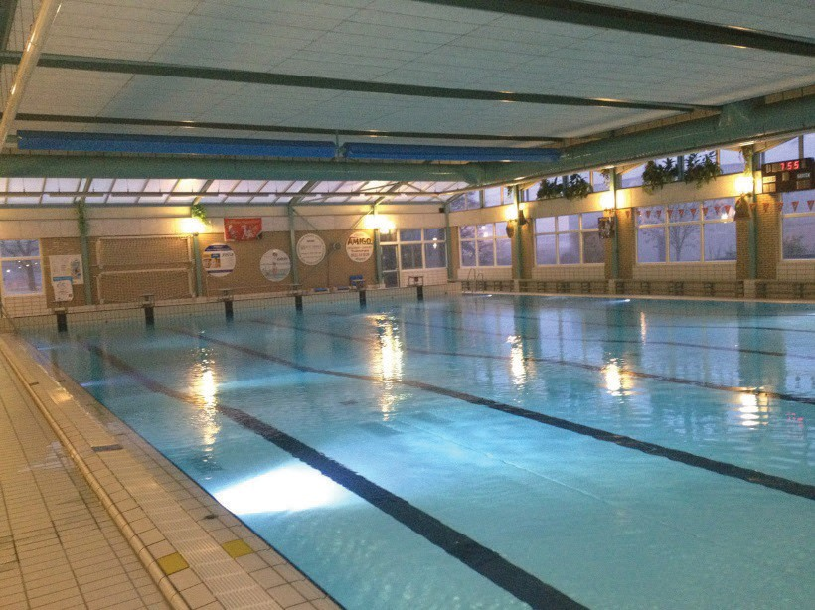

Parameters
(according to law) STAGE 0 STAGE 1 STAGE 2 STAGE 3
Date | 12-  03 | 07-  04 | 19-  05 | 14-  07 | 08-  09 | 03-  11 | 29-  12 | 23-  02 | 24-  04 | 12-  07 | 09-  08
Visibility | botto m | botto m | botto m | botto m | botto m | botto m | botto m | botto m | botto m | botto m | Botto m
pH | 7,1 | 7,3 | 7,2 | 7,3 | 7,4 | 7,3 | 7,5 | 7,4 | 7,3 | 7,2 | 7,4
Free Chlorine (mg/L) | 0,7 | 0,9 | 1,0 | 1,0 | 0,8 | 1,0 | 1,1 | 1,2 | 1,0 | 0,9 | 0,8
Total Chlorine  (mg/L) | 1,4 | 1,4 | 2,0 | 1,4 | 1,2 | 1,4 | 1,4 | 1,5 | 1,3 | 1,0 | 0,9
Combined Chlorine  (mg/L) | 0,7 | 0,5 | 1,0 | 0,4 | 0,4 | 0,4 | 0,3 | 0,3 | 0,3 | 0,1 | 0,1
KMnO4-usage  (mg/L) | 8,3 | 12,0 | 16,0 | 6,2 | 4,9 | 6,3 | 5,4 | 6,4 | 4,2 | 4,1 | 4,8
Urea (mg/L) | 0,5 | 0,5 | 0,8 | 0,8 | 0,8 | 0,8 | 0,6 | 0,8 | 0,6 | 0,5 | 0,5
Aeroob colony forming 360C (kve/mL) | < 1 | < 1 | < 1 | < 1 | < 1 | < 1 | < 1 | < 4 | < 1 | < 1 | < 1
Temperature (0C) | 27,4 | 27,9 | 28,2 | 28,2 | 28,6 | 28,4 | 28,2 | 28,5 | 28,3 | 28,3 | 28,3
Turbidity | 0,5 | 0,5 | 0,5 | 0,11 | 0,16 | 0,12 | 0,27 | 0,15 | 0,09 | 0,20 | 0,21
Sum THM’s | 46 | 56 | 61 | 33 | 24 | 27 | 45 | 43 | - | 30 | 25
Trichloramine (air) |  | 495 | 515 | 226 |  | 192 | 174 | 230 |  | 165 | 261
Fresh water per bather | 45 | 46 | 23 | 23 | 15 | 12 | 18 | 12 | 15 | 19 | 28

Comments:

1. The test results from 19/05 with AFM® were disappointing. The reason for this was because the operator was afraid to lose AFM® during the backwash, and therefore did not use one of two backwash pumps. Consequently, the filter was only backwashed with
10 gpm velocity instead of the required 18 gpm.

2. At 18 gpm backwash velocity, the results were 30 – 50% better compared to sand – with
50% less fresh water = factor 4

3. The maximum allowable level of combined chlorine in the Netherlands is 0.6 ppm. In order to attain 0.2 ppm Chloramine or less, a 2-4 in. layer of activated carbon is requi- red (only indoor pools).

4. Water and air quality are much better today. The water looks clearer with much less tur- bidity

5. The return on investment (ROI) with this project was less than 2 years. The savings in chlorine and acid were not included in this calculation – only water and heating costs!

Overview of important parameters:

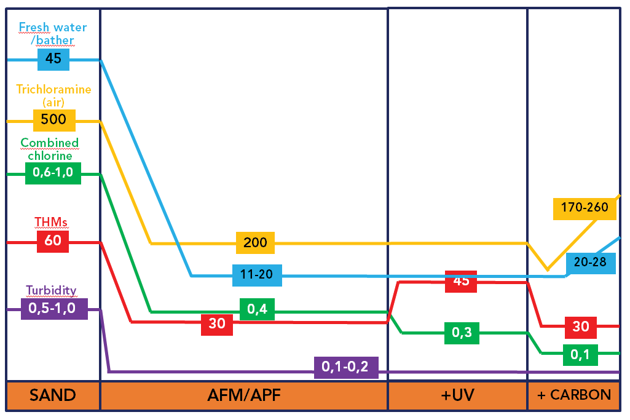

Example from Switzerland: Freibad Rheineck (Public outdoor pool)
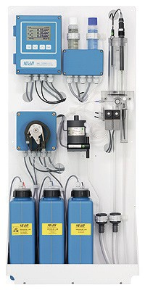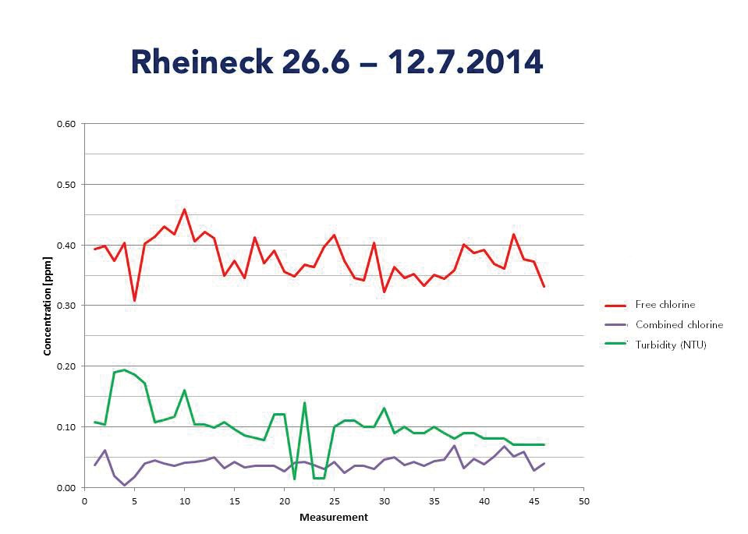

Comments

• Full DAISY® ( AFM®, APF®, ZPM and ACO®)

• All water parameters were measured every 10 minutes with a photometric SVAN unit during a hot-weather period of 3 weeks.

• Average turbidity is below 0.1 NTU

• Average combined chlorine levels are below 0.05mg/l

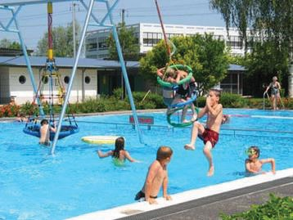• Chlorine and acid consumption was reduced by approx. 25% in comparison to the previously installed sand system

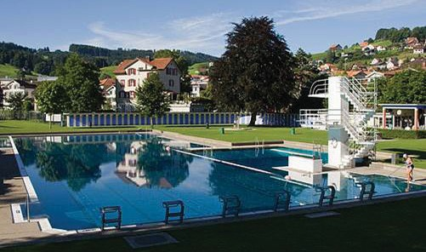

Dryden Aqua Integrated SYstem – Dryden DAISY®

The filter and the filter media are the heart of every water treatment system. Dryden Aqua developed a system where all components work perfectly together to provide the best and safest water and air quality. The Dryden DAISY® consists, beside AFM®, of the following products:

APF® and ZPM

APF® is a high concentrated multi-spectrum flocculant and coagulant. Together with AFM® it can achieve a filtration performance of up to 0.1 micron. Additionally, particles in solution like phosphates are coagulated and filtered. Without phosphates algae and bacteria cannot survive. Because the coagulation process needs a very turbulent environment, we recommend dosage of APF® via our static “ZPM“ mixer. The ZPM is grounded, therefore electrons can be peeled off, thereby reducing the Zeta potential and improving the flocculation process.

ACO®

ACO® is a chlorine stabiliser and photo catalyst. ACO® protects the chlorine from the photo oxidation of the Sun and increases the half-life time of chlorine by a factor of 4. The sun is kind of a huge, natural UV-system. The shortwave light has a lot of energy that divides water molecules to create OH-radicals (free radicals). These are the most efficient oxidising agents we know and they react in a few seconds. ACO® improves this reaction (catalyst) - ACO® increases the natural disinfection power of the sun. The result is much better water quality, less DBPs and less chlorine demand.

Conclusion: ACO® saves chlorine and improves the water quality in all outdoor pools

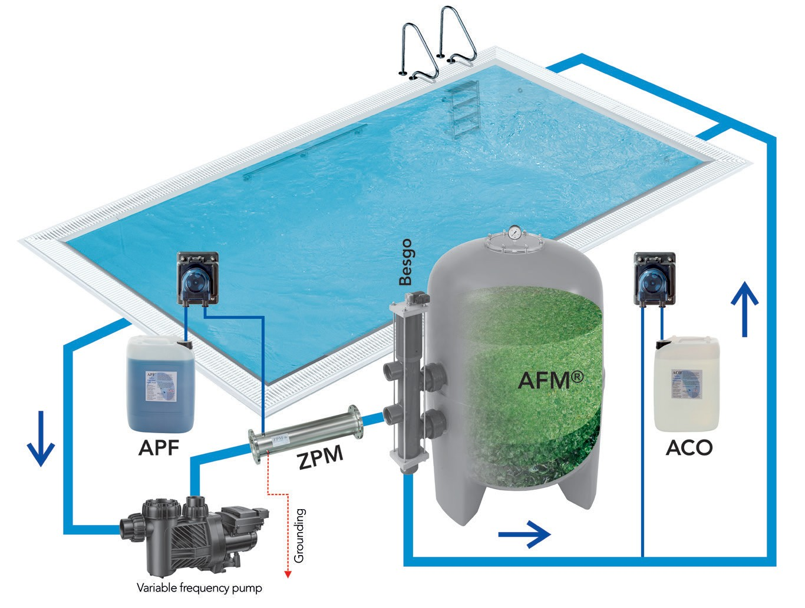

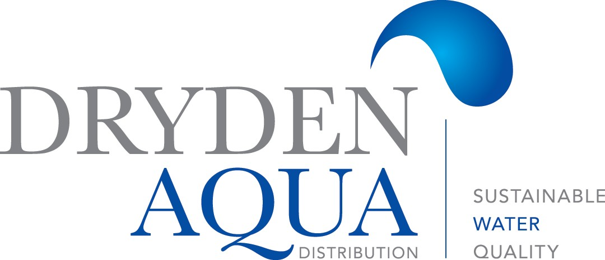

Your competent partner:

Innovative technology in harmony with nature

Who is Dryden Aqua?

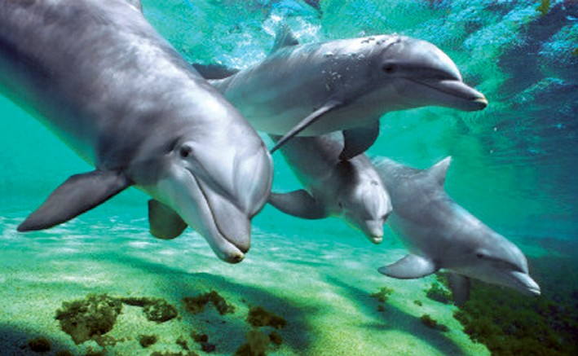
© Dryden Aqua, 11-2017

www.drydenaqua.com

We are a marine biological company specializing in water quality and innovative, sustainable treatment technologies. Our unique knowledge combination and detailed understanding of the biological as well as physio-chemical reactions has enabled us to develop a highly innovative range of products for aquaria and swimming pools. Therefore we became leader in water treatment for public and private swimming pools.
Our mission is: crystal clear and healthy water without any smell of chlorine. Today more than 200‘000 pools worldwide are using our system.

